Lifecycle Definition Document

生命周期定义文件

|  |  |  |
| --- | --- | --- |
| Author | Reviewer | Approver |
|  |  |  |

**Version Control**

|  |  |  |
| --- | --- | --- |
| **Version** | **Date** | **Description** |
| 0.1 | 09/09/2019 | First document release |
| 0.2 | 19/10/2020 | Minor changes |
|  |  |  |
|  |  |  |

**Contents**

1 Purpose and Scope 4

1.1 Responsibility 4

2 Facility Description 5

2.1 Site Location 5

2.2 Site Description 5

3 Production Process 8

3.1 Die Bond 9

3.2 Wire Bond 11

3.3 UV/Molding 11

3.4 Electronical Testing 12

3.5 Visual Inspection 12

4 General 13

4.1 Storage 13

4.2 Defective modules and sensitive materials 13

4.3 Production plan 13

4.4 Production Documentation 14

5 Bibliografía 15

1. Purpose and Scope

This document is the Lifecycle Definition Document of CTWY.

本文档为澄天伟业站点的《生命周期定义文件》。

This document describes the part of the lifecycle carried within the CTWY.

本文档描述了在澄天伟业中进行的生产活动的生命周期

* 1. Responsibility

The production group is responsible for the securely production, and the procedure document formulation, the general manager is responsible for approving this document.

生产部负责生产安全管理，并编制本流程，总经理负责审批本文件.

1. Facility Description
   1. Site Location

Name: Ningbo Chengtian Weiye Production Centre

Location:

*No.8, Binjiang Road,*

*Cixi High-tech Industrial Development Zone,*

*Ningbo City, Zhejiang Province, P. R. China.*

This location is a building, which belongs Chengtian Weiye (Ningbo) Chip Technology Co.,Ltd, described as Ningbo Chengtian Weiye Production Centre. This building consists of only one floor; The production floor which conducts the electric testing, IC assembly and packaging into rails.

* 1. Site Description

There are three sides of perimeter walls and one side of a river surrounded the factory premise. An entry gate of the perimeter wall guarded by security guard. CCTV cameras are deployed in both the perimeter walls and the premise’s wall facing the river and all the CCTV cameras are connected to the security room located within the premise.

工厂厂房三面围墙，另外一面被一条河阻挡。只有一个围墙入口，有安保把守。三面围墙和面向河岸的厂房外墙都部署了CCTV摄像头，并连接到位于厂房内的安全控制室。

Security guard will cruise the roads within the perimeter walls every two hours during daily time. Security guard will be on duty for 24 hours and 7 days per week.

白天安保会每两个小时在工厂围墙内的路上巡逻。安保7天24小时值班。

Access to the factory premise is controlled by doors equipped with physical access control system where the control panel of the system is deployed in security control server room.

进入厂房的门装备了门禁系统，门禁系统的控制端部署在安全控制室。

The whole floor from the main building in Ningbo CTWY Production Centre and the network & server room are located in the same building. Both are in the scope of this SST. Additionally, guard services, access control and surveillance restrict and control the access to CTWY production area. The site includes security control room, security control server room, vault, receiving/sending area, security IC packaging workshop, IT server room and reliability testing room.

整个宁波澄天伟业站点都包含在SST描述的范围内。此外，澄天伟业生产车间也部署了门禁以及监控措施。站点包括安全控制室、安全控制室机房、金库、收发区域、安全芯片封装车间、IT服务器机房和可靠性测试间。

1. The following service and/or processes provided by CTWY are in the scope of the evaluation process:

* Reception, identification, registration and storage of sawn wafers;
* Wire bonding;
* Die bonding;
* Quality control testing for incoming raw materials and each production process;
* Functional testing and visual inspection of finished modules;
* Warehousing and dispatch of finished modules;
* Scrap recycle and return to clients if required.

以下澄天伟业提供的服务以及流程都包含在本次评估的范围内：

* 已经减划好的硅圆的接收、标识、入库登记以及储存
* 贴片
* 焊线
* 成品功能测试以及目检
* 成品仓储以及发货
* 废品回收返还至客户

The complete flow of the security IC modules for smart card product at the site is covered by the SST. In addition, the management of the security IC modules for smart card related processes and the site security are covered by the SST. The production flow of the security IC modules on the site starts with the receipt of parts of the product (raw materials) up to the packing and handover for shipment of the finished security IC modules.

智能卡产品的安全芯片加工流程都已在SST中进行了描述。此外，相关流程的安全芯片模块的管理以及站点的安全也都在SST中进行了描述。本站点进行的安全芯片模块的生产流程起始于原材料的接收，止于成品包装发送至客户。

The current evaluation is based in the life cycle described in *EUROSMART. Security IC Platform Protection Profile with Augmentation packages. Version 1.0, 2014 protection profile* but not limited to this PP.

当前的评估基于EUROSMART. Security IC Platform Protection Profile with Augmentation packages. Version 1.0, 2014 protection profile中的生命周期描述, 但不仅限于此 防护档案.



The following life-cycle phase of the Security IC modules can be subjected (but not restricted) as example to the protection profile (1):

安全IC模块的以下生命周期阶段可以（例如但不限于）以保护规范为例:

* Life cycle phase 4: IC Packaging 生命周期第四阶段：IC封装
  + Security IC packaging (and testing) 安全芯片封装(以及测试)

1. Production Process

Production process covered by the site is divided in the following stages：

本站点涉及到的生产流程可以划分为以下几个阶段:

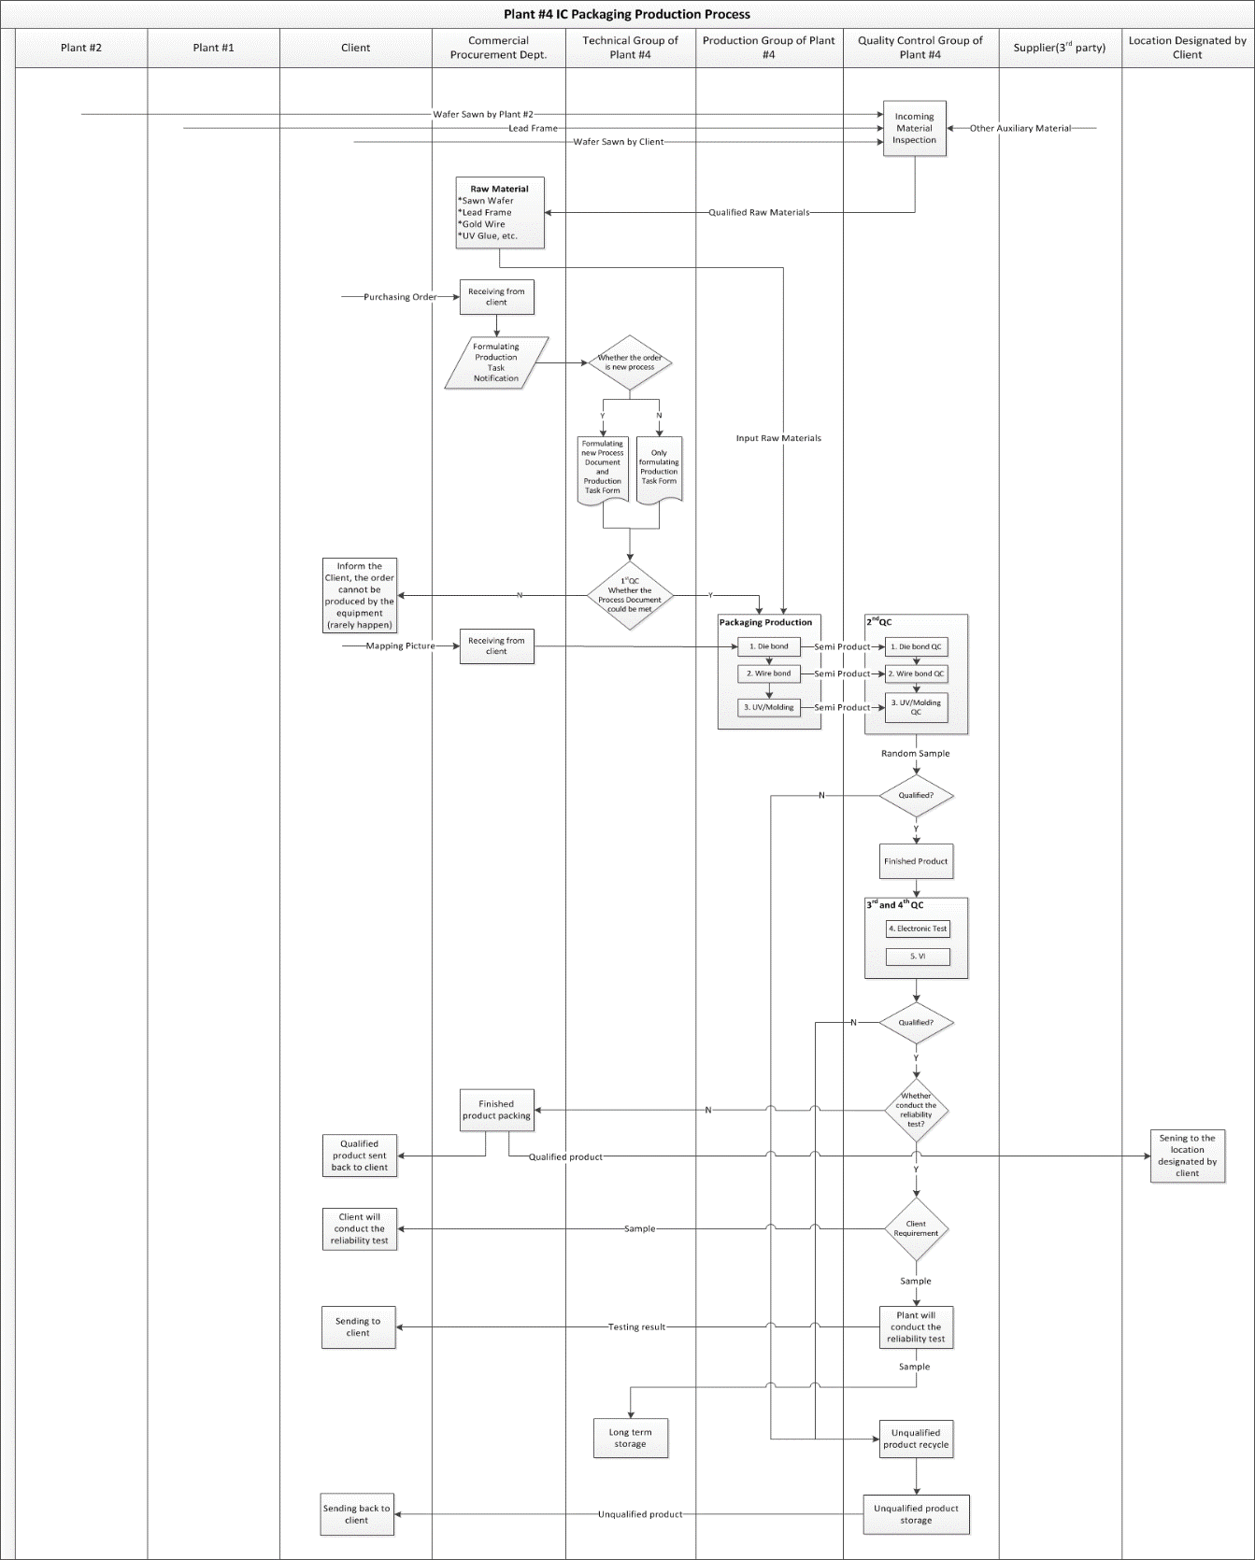

Figure 1 Plant #4 IC PACKAGING pRODUCTION PROCESS

following parts for the process are received before packaging production process and consist in:

在封装生产开始之前，需要准备以下产品：

* **Wafers**: sawn wafers containing the ICs for packaging. The mapping file related to identify the disqualified dice on wafer is delivered from client to the Sales Department.

**硅圆**：包含有芯片的，已经减划好的硅圆被用于封装。《比对文件》被用于识别硅圆上无法正产使用的芯片，《比对文件》由客户发送至销售部。

* **Lead Frames**: packed in reels which are provided by warehouse for the IC to be assembled into on stage Die Bonding and Wire Bonding .

**载带**：由仓库提供卷盘载带，用于贴片以及焊线。

* **UV** **Glue**: for fixing IC into lead frames in stage “UV/Molding”.

**UV胶**：用于UV/Molding 工序中，将芯片固定在载带上。

* **Wire**: gold wire for bonding the IC to the external pins of lead frame.

**金线**：金线作为外部引脚将芯片固定在载带上。

Other materials could be required for particular IC model assembly.

其余的材料，个别芯片模块在封装时可能会需要。

The following is applicable for problems in the produced modules along all the stages:

以下方式用于处理在模块封装过程中遇到的问题：

* All the disqualified modules are punched a hole on the reel not to be used by client.

所有的不合格模块都将被打孔，避免客户误用。

* The continuous disqualified modules on the lead frames are cut from the reel, recycled in the disqualified recycle bin and sent back to the client. The [dispersive](javascript:;) disqualified modules on the lead frames will be left in the orignal location cause of the inconvenience to cut from the reel.

在载带上连续的不合格模块，都将被从载带上剪下来放入不合格品回收箱，发还给客户。单独的不合格模块，由于不方便剪下来，将继续留在载带上。

* 1. Die Bond

Die bonding is carried out within the production area.

贴片流程在生产区域中进行。

Die bond machine are loaded with the PCBs that are arranged in a strip and rolled in a reel.

操作员先将卷盘载带安装在贴片机上。

Die bond machine takes the ICs one by one from the wafer and put each one on a different PCB by following the mapping file. The mapping file identifies the ICs that are disqualified by the IC manufacturer and marked ICs are skipped by the machine in the process.

贴片机将会按照《比对文件》从硅圆上将合格的芯片一片一片贴到载带上。芯片生产商在《比对文件》中将不合格的芯片进行标识，确保贴片机能够吸附合格的芯片。

After bonding, the set of IC glued to PCB by epoxy resin is called modules. Bonded modules are rolled up in an output reel and protected with a special strip for protecting them from the dust and dirt.

在贴片结束之后，涂环氧树脂，用于将芯片固定在载带上。所有贴片好的模块将会通过卷盘存放于载带上，同时通过特殊的保护膜来保护载带表面不会受到灰尘的污染。

Together with the output reel, the operators write the related production information on the Production Tracking Card (herein after called T-card), describing the quantity and characteristics of modules produced:

操作员将贴片工序相关的生产信息填写在《生产跟踪卡》上 (之后简称为T卡)，来记录模块的生产数量以及特性如：

* Production Lot Number生产批次号
* Wafer Number硅圆编号
* Product Type产品型号
* Operators操作员
* Quantity数量
* Time贴片时间
* Other associate information以及其他相关信息

This card will follow each particular reel of modules along the rest of the production process: Before each production process, the QC group must confirm and sign on the T-card, after the quality inspection for the few pilot samples, and approve to start the massive porduction.

T卡将会在之后的所有生产工序中流转：在每道工序开始之前，质检组必须进行首检，首检确认通过之后，质量部将在T卡上签名，随后将进行批量生产。

Besides the T-card, the following forms are also filled by the operators of the Die bonding production process:

除了T卡之外，以下表格也会在贴片工序中填写

* Die bonding production process operating record 贴片工序操作记录
* Wafer processing record 硅圆加工记录
* Lead frame using record 载带使用记录
  1. Wire Bond

Operator loads the wire bonding file, the reel with the modules, the gold wire reel and SPT GAISER into the production machine. Bonding file describes terminal location of the IC and soldering times and temperatures.

操作员将焊线工序文件、卷盘载带，金线卷以及瓷嘴安装在焊线机上。焊线工序文件描述了芯片终端的焊接位置，以及焊接时间和温度。

Machine takes one by one the modules and bonds the IC terminations (in the silicon) to the PCB

terminations (copper terminations accessible from the exterior) with the wire by following the bonding file.

焊线机将自动按照焊线工序文件，将模块上的芯片终端 (在芯片上) 与载带上的终端 (可从外部焊接的铜质终端) 通过金线焊接起来。

After bonding, modules are rolled up in an output reel and protected with a special strip for protecting them from the dust and dirt and T-card is updated.

在焊线结束之后，所有焊线完毕的模块将会通过卷盘存放于载带上，同时通过特殊的保护膜来保护载带表面不会受到灰尘的污染，同时操作员在T卡上录入焊线工序的生产信息.

* 1. UV/Molding

Operator loads the machine with the modules arranged in a strip and rolled in a reel.

操作员将卷盘载带安装在生产设备上。

Machine takes one by one the modules and disposes a quantity of epoxy resin to cover the IC within package. This resin is toughened up by UV.

生产设备将环氧树脂覆盖于模块上，将芯片覆盖在内，同时通过紫外线来增加韧性。

After molding, modules are rolled up in an standard output reel (with the plastic plank) and T-card is updated.

在滴胶注塑工序结束之后，模块将会通过标准出料盘 (通过塑料支撑的) 存放于载带上，同时操作员在T卡上录入注塑工序的生产信息.

* 1. Electronical Testing

Operator loads the testing machine with the modules arranged in a strip and rolled in a reel and the testing file with electrical parameters for testing.

操作员将装有模块的卷盘载带放在测试仪器上，通过测试程序分析比对电性参数。

After testing, modules are rolled up in an output reel and T-card is updated.

电性测试结束之后，模块将会被卷回卷盘条带，同时，操作员将测试结果录入T卡

* 1. Visual Inspection

Visual inspection is carried out manually by operators on the finished reels. Operators inspect one by one the finished modules and punch the holes on the discarded ones not to be used by the punching forceps.

目检由操作员手动对成品卷盘载带来执行。用打孔钳在相应位置打孔标识出不合格的模块。

After VI, modules are rolled up in an output reel and T-card is updated.

目检结束之后，模块将会被卷回卷盘条带，同时，操作员将测试结果录入T卡。

The QC label will be printed and attached on the finished products after the VI, the following information will be included in the QC label:

在目检结束之后，操作员将会打印《合格证》，包括以下信息:

* Wafer Lot 硅圆批号
* Client product Lot 客户产品批号
* Lead frame type 载带型号
* Size 尺寸
* Quantity 数量
* Inspector 检验员
* Date 日期
* Discarded hole quantity 废孔数
* Production Number 生产编号
* Material Code 物料代码

1. General

The following general considerations have to be considered:

必须考虑下列一般性想法:

* 1. Storage

Raw materials (glue, wire, epoxy resin), TOE parts, defective parts, incoming sawn wafers and outgoing finished products are stored within the warehouse and protected by security measures designed for it when are not being processed or in use.

原材料(滴胶、金线、环氧树脂)、TOE部分、不合格成份、减划好的硅圆以及封装好的成品都储存在仓库中，同时仓库中部署了相应的安全保护措施来确保即使在没人看管或者使用时，仓库区域依然安全。

* 1. Defective modules and sensitive materials

By default, disqualified modules and defective sensitive materials from any stage are stored in the recycle bins available.

按照默认的流程，生产工序中涉及到的所有不合格模块以及不合格的敏感物料都将存放在回收箱中。

To unlock the disqualified modules recycle bin monitored by the CCTV needs the key kept by the manager.

只有通过经理保管的钥匙才能打开处于监控下的不合格模块回收箱。

Recycle senstive scrap are sent back to the client through the delivery procedure defined and record the information on the Scrap Wafer Record.

回收起来的敏感废料，都将按照交付程序发还给客户并记录在《废硅圆退库记录表》上。

* 1. Production plan

Production Task Form contains various components information of the final product used in the production process, includes：

《生产任务单》包括成品在生产过程中所需要的所有成份，包括:

* Product Type 产品型号
* Wafer Lot 硅圆批号
* Product Quantity 产品数量
* Lead Frames Type and Quantity 载带型号以及数量
* Gold Wire 金线
* Die Bonding Glue 贴片胶
* Test Standard 测试规范
* Production Lot 生产批号
* Needle Quantity and Type 顶针型号以及数量
* Suction Nozzle Quantity and Type 吸嘴型号以及数量
* Process Document Number 工艺文件号
* Other associate information 以及其他相关信息

The technical group is responsible for designing the Production Task Form and Process Document of each batch of the product.

技术部负责为所有产品制定《生产任务单》以及《工艺文件》。

Restricted access control on ERP system. Only the technical group engineer has the permission to edit the Production Task Form and Process Document on ERP system. The operators on the production line only have permission to read them.

ERP系统中，不同的用户拥有不同权限的账户。只有技术部工程师有权限来在ERP系统中编辑《生产任务单》以及《工艺文件》。产线上的操作员只有读取的权限。

* 1. Production Documentation

Testing standards, packing requirements, and other documentation used for production is available in the ERP system of the company for the production employees.

测试规范，包装要求以及其他的用于生产的文档都储存在ERP系统中供生产员工阅读

1. Bibliografía

1. **EUROSMART.** *Security IC Platform Protection Profile with Augmentation packages.* Version 1.0, 2014.

2. **Common Methodology for Information Technology Secuirty Evaluation.** *Supporting Document, Site Certification.* Version 1.0, Rev.1, October 2007.

3. **Common Criteria for Information Technology Security Evaluation.** *Part 3: Security Assurance Components.* Version 3.1, Rev. 5, April 2017.

4. **Library, Join International.** *Minimum Site Security Requirements.* 2019 April. version 2.2.

5. **Common Criteria for Information Technology Security Evaluation.** *Part 1: Introduction and General Model.* Version 3.1, Rev. 5, April 2017.

6. **Common Methodology for Information Technology Secuirty Evaluation.** *Evaluation methodology.* Version 3.1, Rev.5, April 2017.

7. ***Supporting Document Guidance, Site Certification.* October 2007, Version 1.0.**